Fastli Bug Report
Prepared by: Taka Treasure Chidawanyika
Student Number: 65529
Date: October 28, 2025

1. Placeholder or Dummy Data
- Error: Many listings contain placeholder or meaningless data such as:
  - “fdsfdsfds” (Title)
  - “dsfdsfdsf” (Description)
  - “n” (Title)
- Explanation: These look like test entries or uncleaned data from development/testing stages, which should not appear in a production environment. This reduces credibility and user trust; makes the app appear unfinished or unreliable.

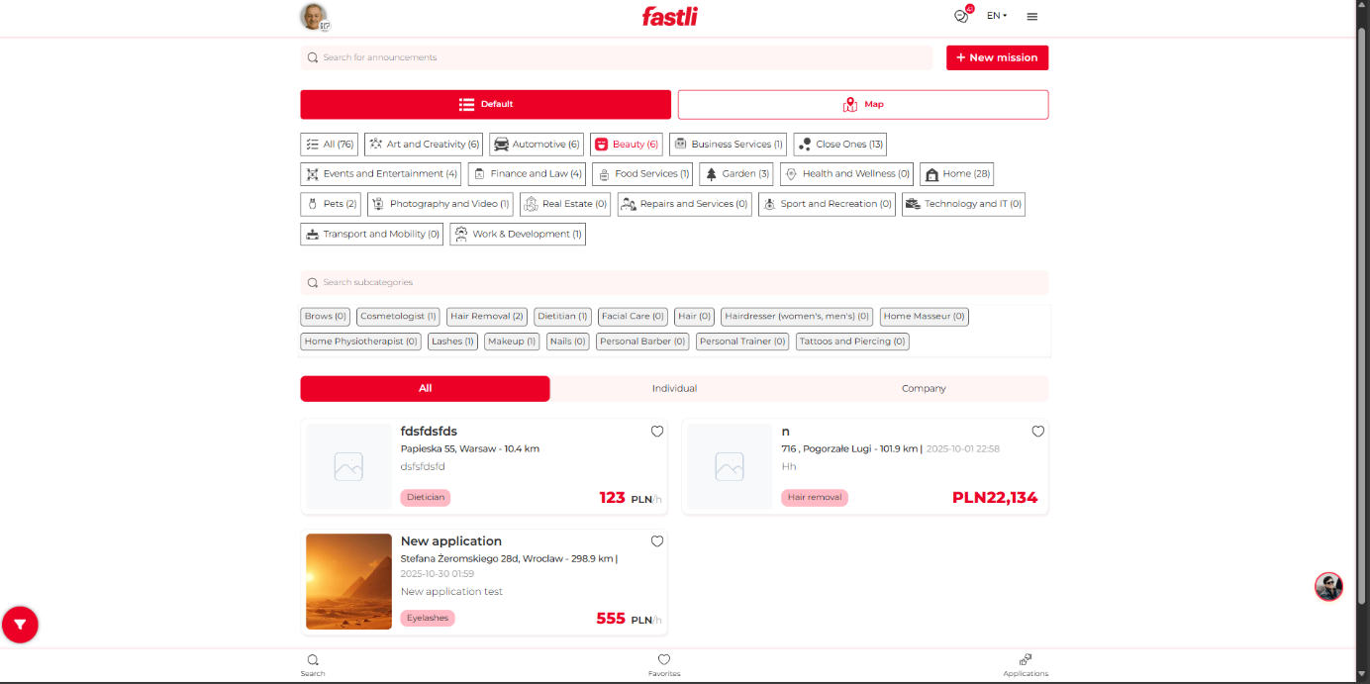

2. Incorrect or Unrealistic Pricing
- Error: A listing shows PLN 22,134 for “Hair removal.”
- Explanation: This price is excessively high and unrealistic for the service, suggesting a data entry or validation error.
- Impact: Misleads users and makes the platform look unprofessional; may affect user engagement or cause confusion.
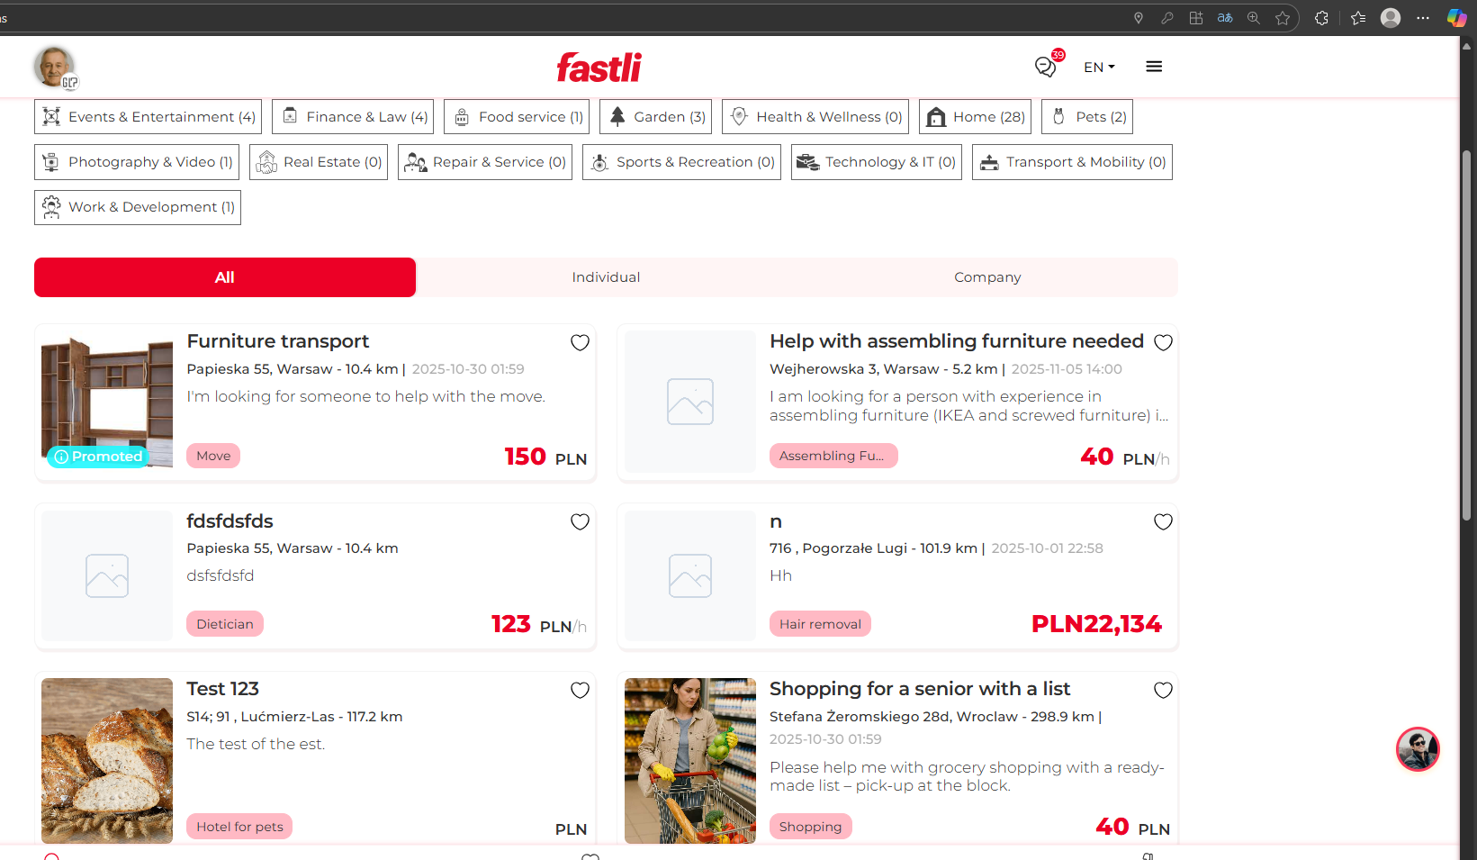

3. Incomplete or Missing Images
- Error: Two listings display a blank image placeholder (broken or missing image icons).
- Explanation: The system likely failed to load or find the assigned image files for these posts.
- Impact: Decreases the visual appeal of the platform and hinders user understanding of what the listing is about.
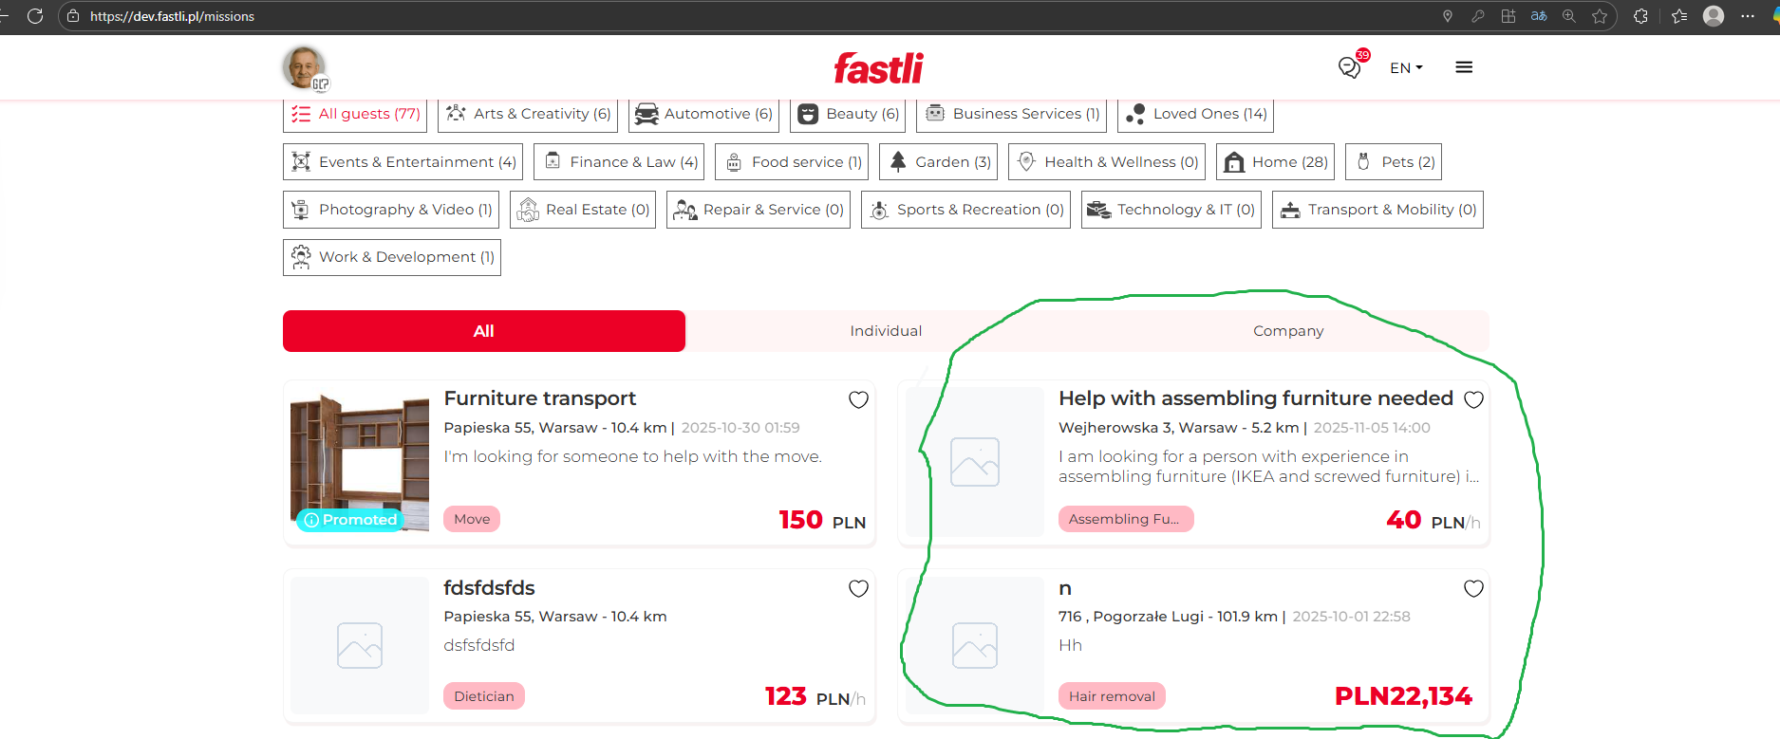

4. Unclear Category Labeling
- Error: Several categories and subcategories show (0) items, e.g., “Home Physiotherapist (0)” or “Technology and IT (0).”
- Explanation: These indicate empty categories that could be hidden until populated.
- Impact: Clutters the interface and frustrates users browsing for available services.

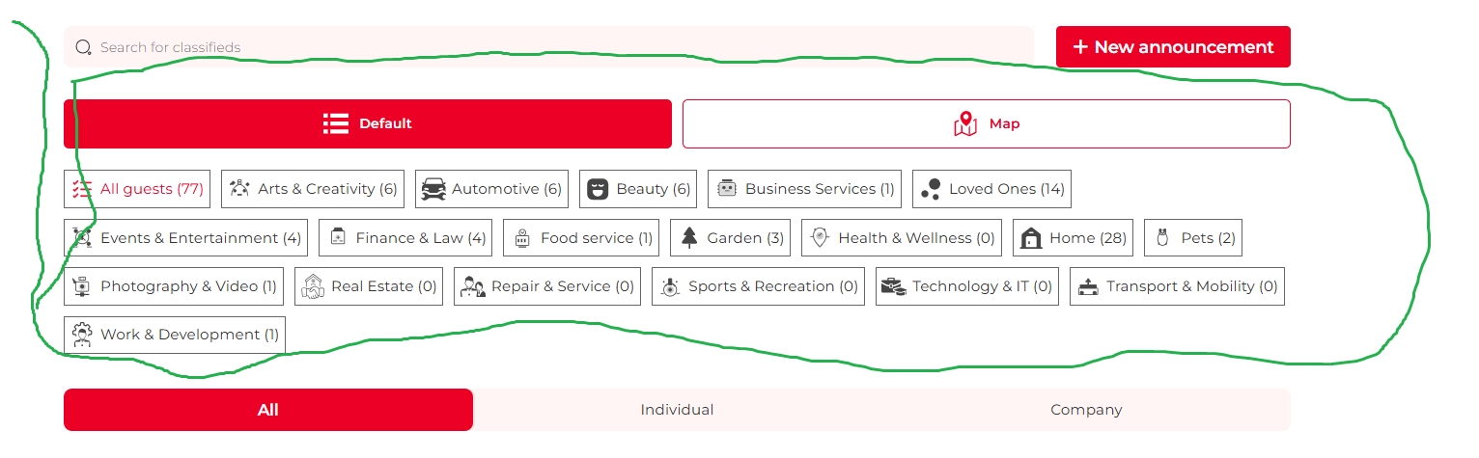

5. UI Inconsistency in Button Highlighting
- Error: The selected tab under “Default / Map” is highlighted in red, but the “All / Individual / Company” tabs use different color intensities and padding.
- Explanation: The lack of consistent color usage and spacing creates an unbalanced visual hierarchy.
- Impact: Confuses users about which tab is currently active.



6. Distance Display Formatting Issues
- Error: One listing shows “298.9 km” away — far too distant for a local service search.
- Explanation: This suggests that the filtering system doesn’t restrict results to a practical radius (e.g., 10–50 km).
- Impact: Users may see irrelevant results, lowering usability and satisfaction.

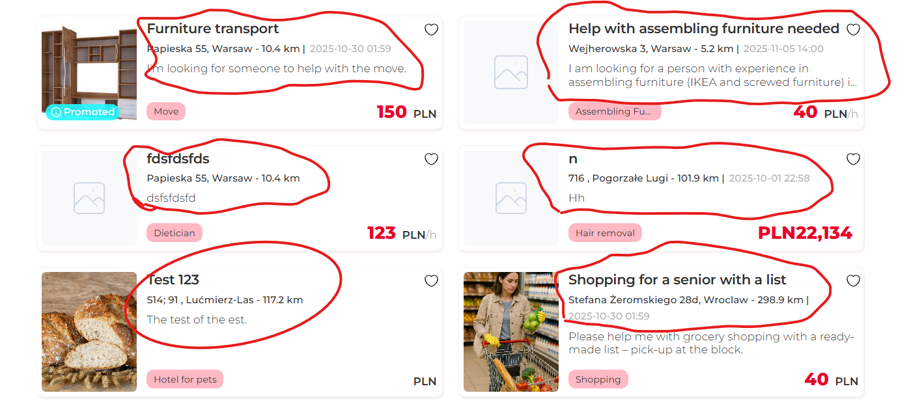

7. Date and Time Format
- Error: Inconsistent or confusing time display, e.g. “2025-10-01 22:58” and “2025-10-30 01:59”.
- Explanation: The system uses ISO format, which is fine for databases but not user-friendly.
- Recommendation: Use a localized, readable format (e.g., “October 30, 2025, 01:59 AM”).
- Impact: Slightly reduces readability and professionalism.

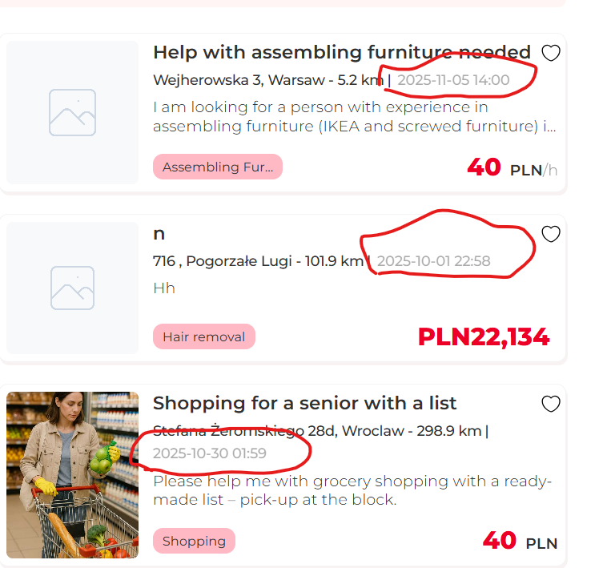

8. Redundant Search Elements
- Error: Two search bars — “Search for announcements” and “Search subcategories” — are placed close together.
- Explanation: The functions may overlap, confusing users about which search field to use.
- Impact: Hurts UX clarity; may lead to user input errors or inefficiency.

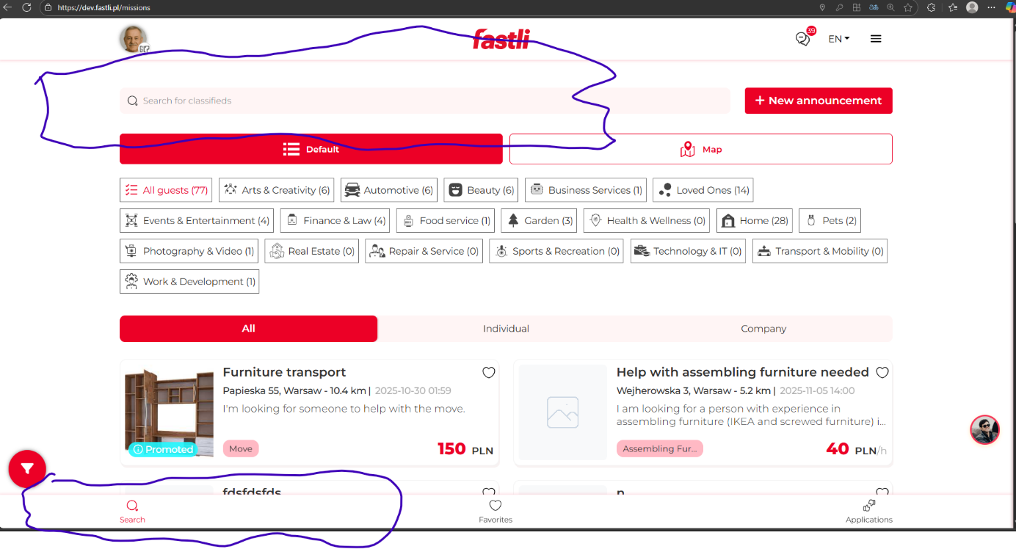

9. Unresponsive Message Tab
- Error: Clicking on the message tab does not trigger any action.
- Explanation: This tab is intended to provide access to email services such as Gmail and Outlook, enabling users to compose and send messages.
- Impact: Users are unable to send email messages, which limits communication functionality.

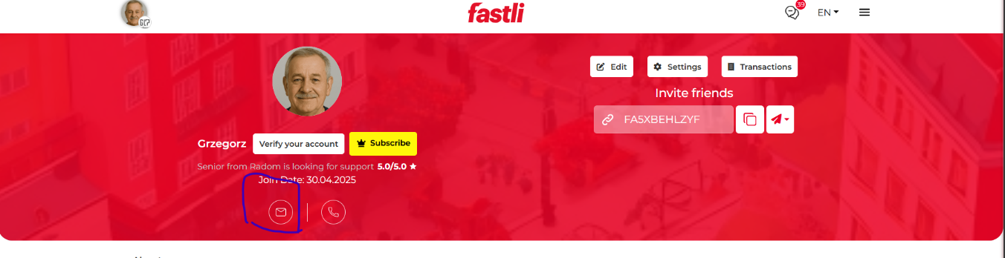

10. Incorrect user location
- Error: The map is showing an incorrect location of the user’s address
- Explanation: The location displayed on the map is not where I stay. It’s an entirely different location.
- Impact: This error misleads users since they will be seeing a different location on the map

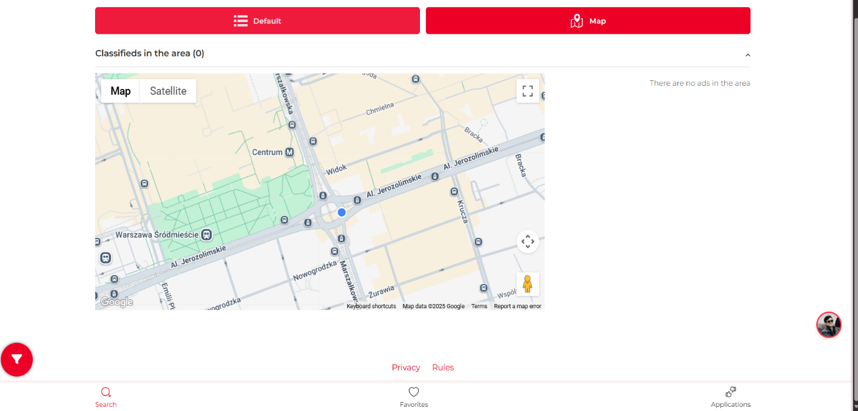

11. No Messages Displayed
- Error: Messages fail to appear when the message tab is clicked.
- Explanation: Although the tab indicates that messages are present, clicking it does not display any content.
- Impact: Users are misled and unable to access their inbox, preventing them from reading messages.
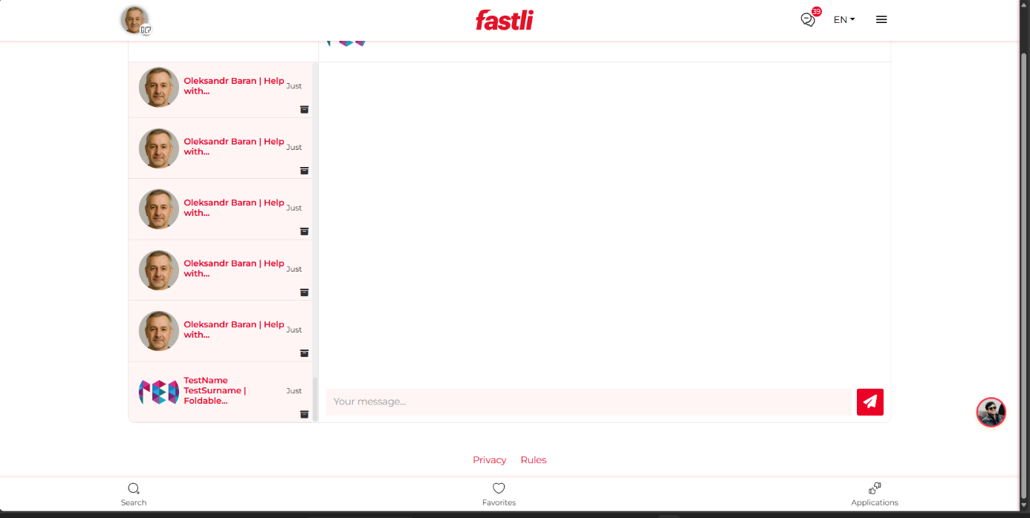

Testowanie aplikacji fastli:\\\\n1. www.dev.fastli.pl\\\\n2. Założyć konto (jeżeli nie działa, skorzystaj z punktu nr.3\\\\n3. log: grzegorz.maj@glpsoftware.pl \\\\\\\\n pass: 123123\\\\n4. Prześledź każdą ścieżkę po kolei. \\\\n5. Do każdego znalezionego błędu dołącz zrzut ekranu z oznaczeniem np. strzałką lub podkreśleniem na inny kolor + link\\\\n6. Możesz dać swoje propozycje co zrobić, aby usprawnić korzystanie z aplikacji\\\\n7. Raport prześlij w Wordzie

